Lab Exercise 2: Working with Docker Volumes
Objective:
- Learn how to create and manage Docker volumes.
- Understand how Docker volumes can be used to persist data across container restarts.
- Practice mounting Docker volumes to containers.
Prerequisites:
- Docker installed on your system.
- Basic understanding of Docker commands and container concepts.
Step 1: Create a Docker Volume
Create a new Docker volume:
docker volume create my_data_volume
This command creates a Docker volume named my_data_volume.
Verify that the volume was created:
docker volume ls
You should see my_data_volume listed among the volumes.
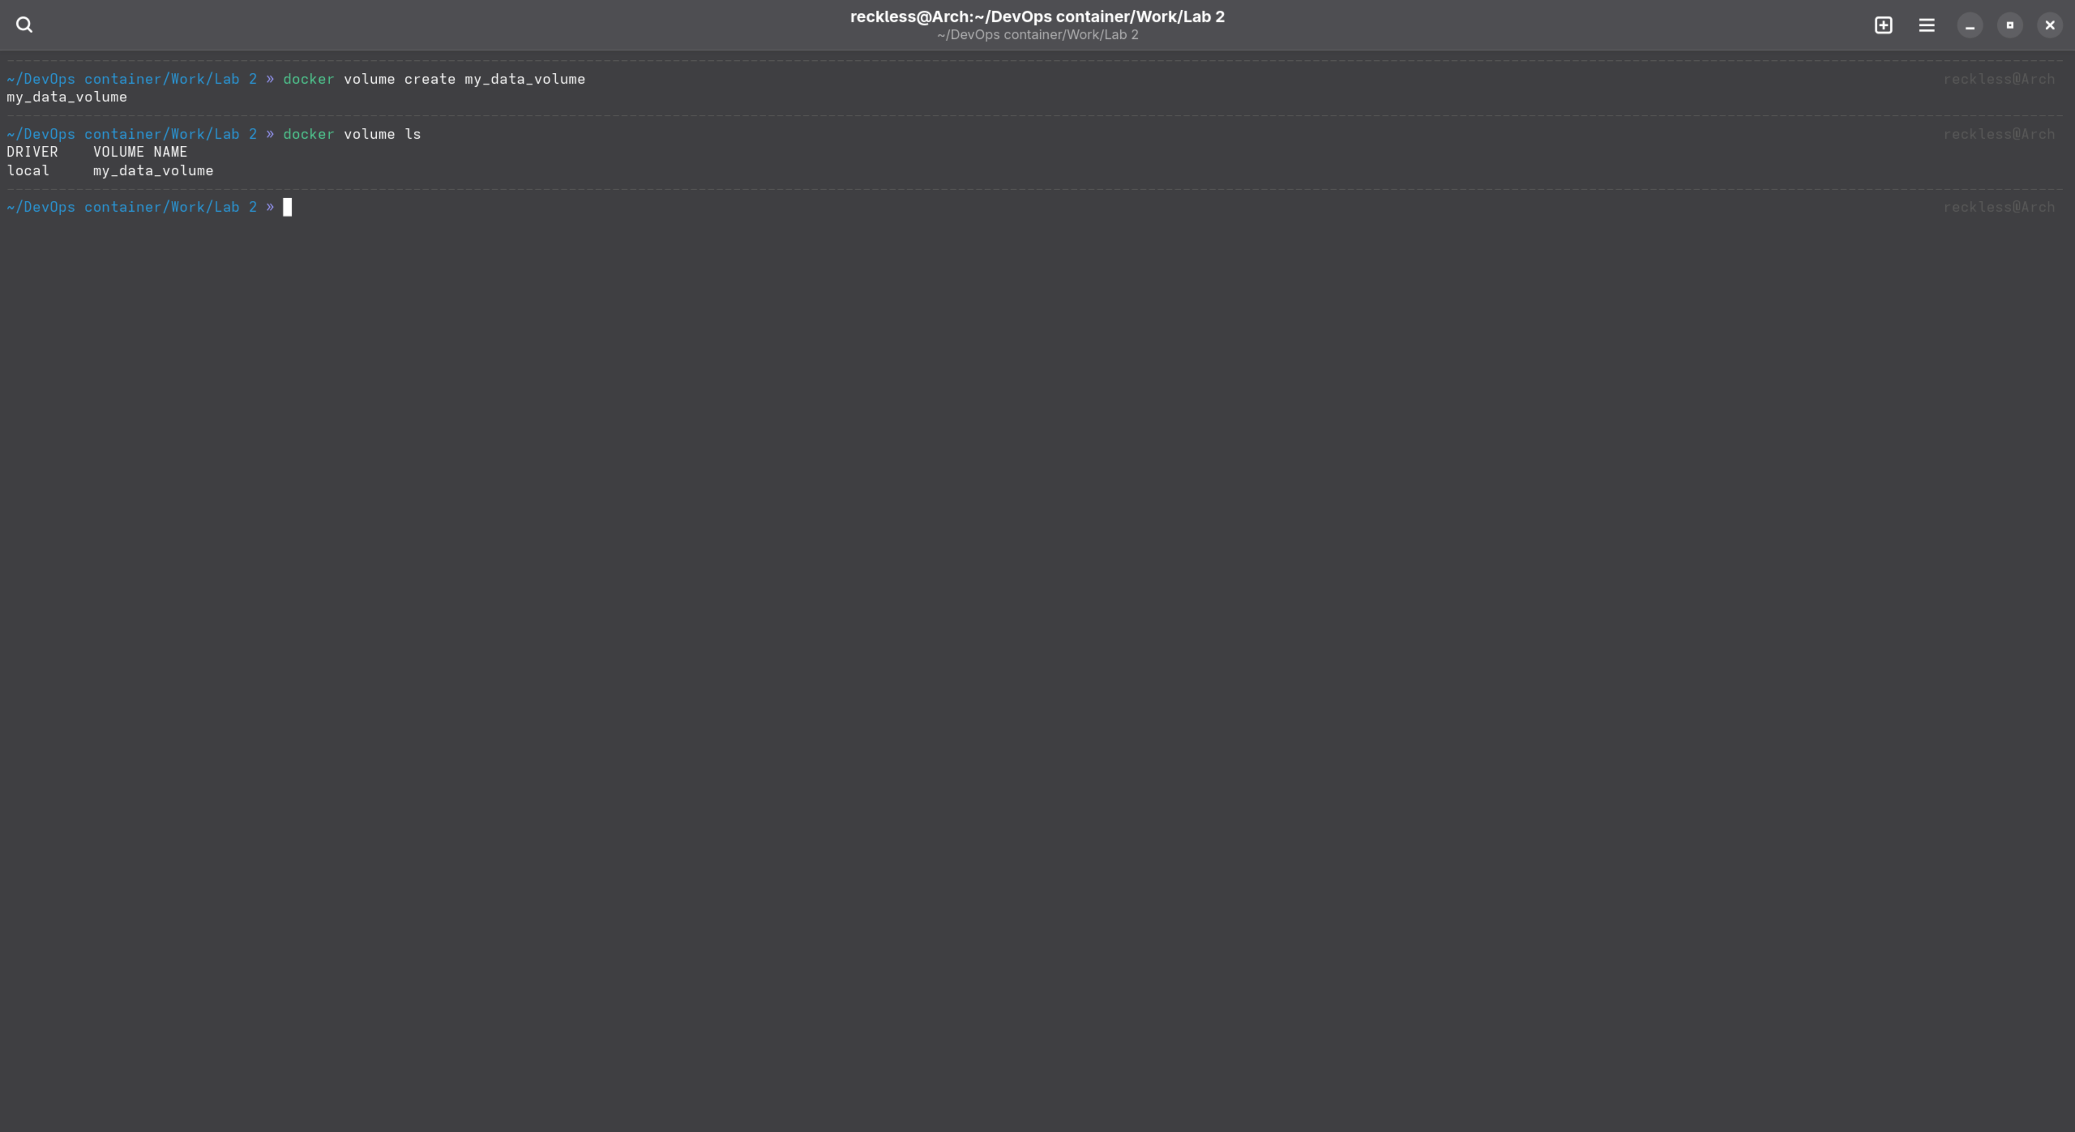

Step 2: Run a Container with the Volume Mounted
Run an Nginx container with the volume mounted:
docker run -d --name my_nginx -v my_data_volume:/usr/share/nginx/html -p 8008:80 nginx
This command starts an Nginx container named my_nginx and mounts the my_data_volume volume to the /usr/share/nginx/html directory inside the container.

Verify that the container is running:
docker ps
You should see my_nginx listed as one of the running containers.
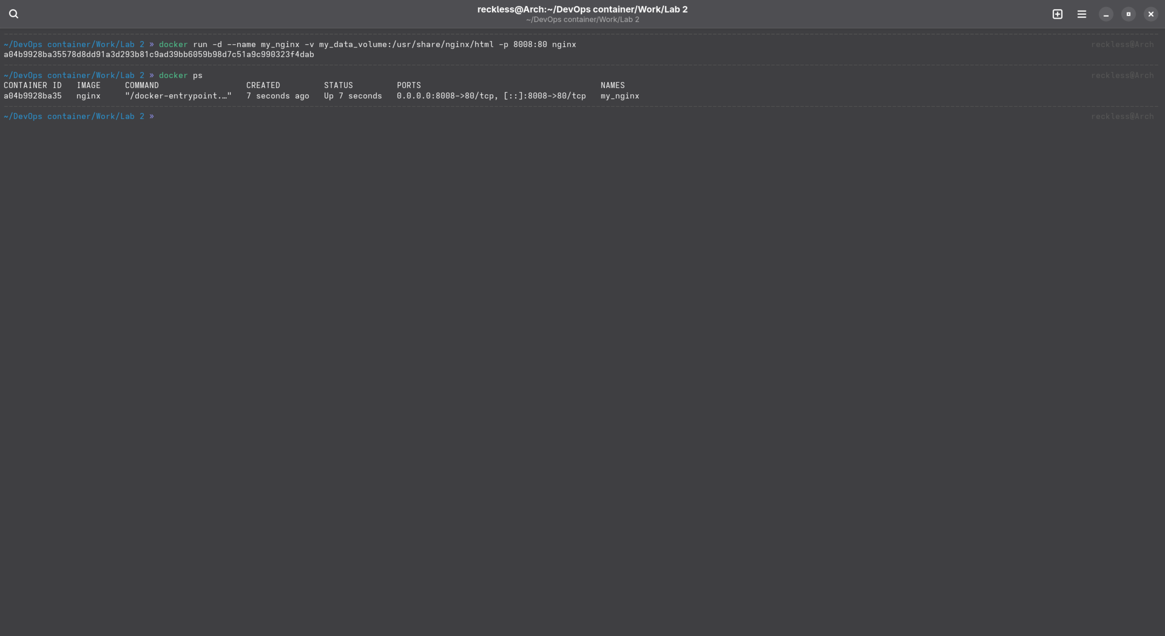
Step 3: Interact with the Volume
Create a simple HTML file in the volume:
docker exec -it my_nginx bash
echo "<h1>Hello, Docker Volume</h1>" > /usr/share/nginx/html/index.html
exit
This command creates an HTML file inside the /usr/share/nginx/html directory, which is backed by my_data_volume.
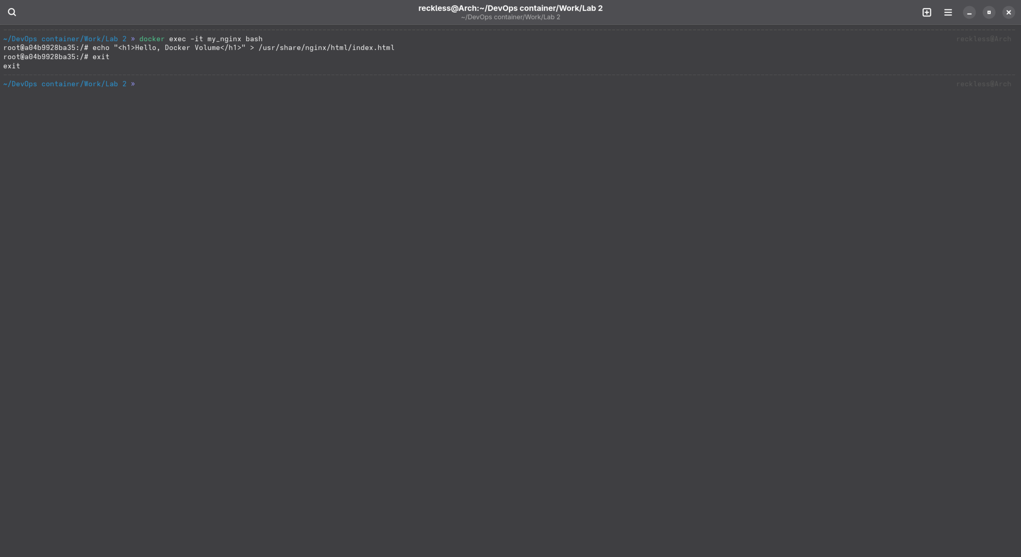
Access the Nginx server to see your file: Open a browser and navigate to http://localhost:8008. You should see the message "Hello, Docker Volume!" displayed on the page.

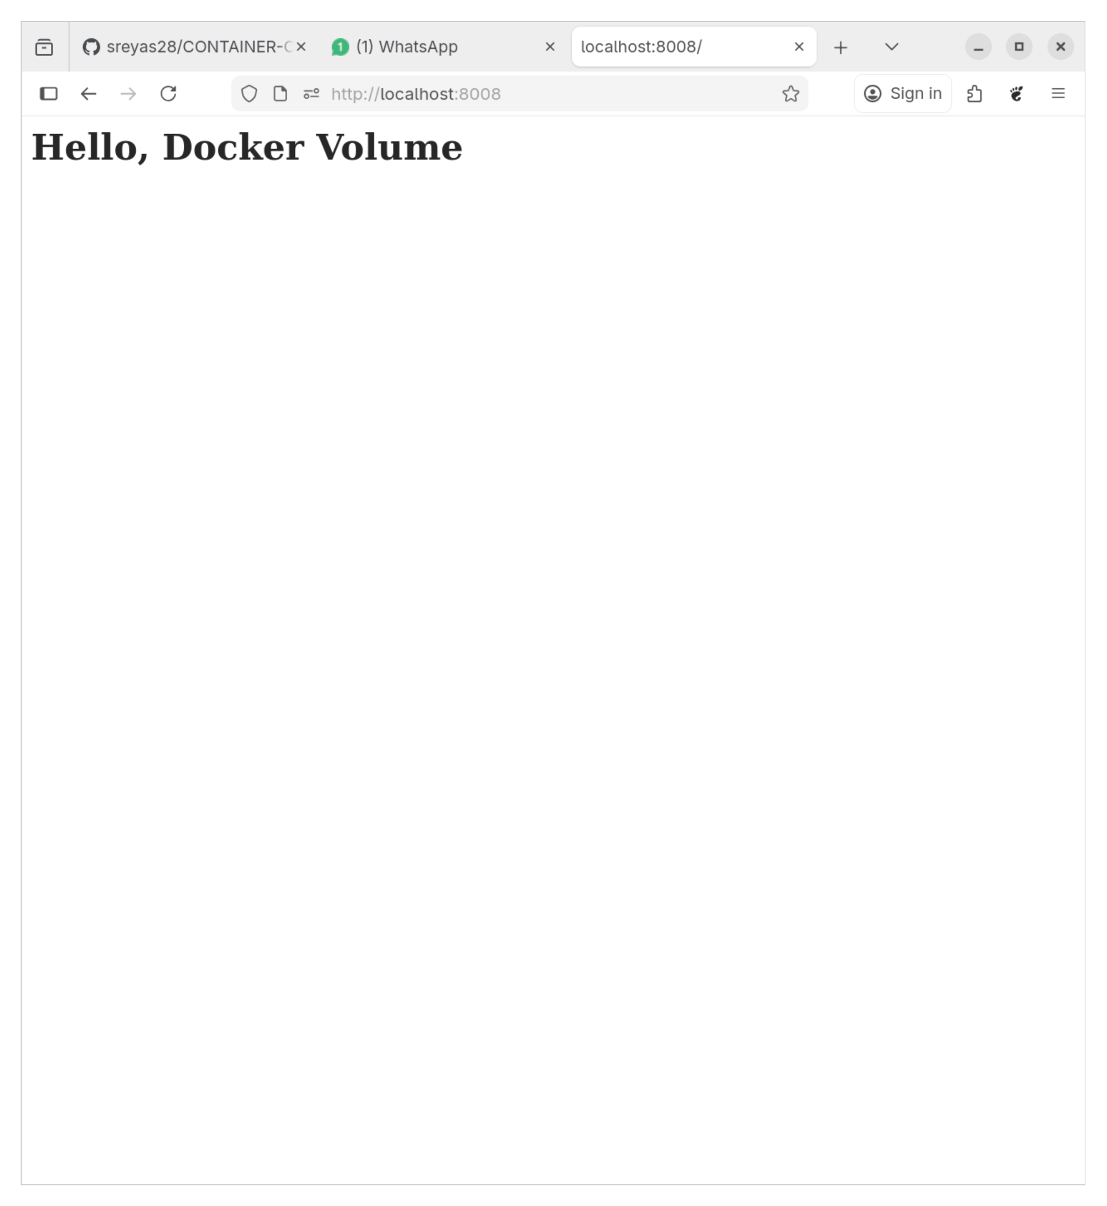
Step 4: Test Data Persistence
Stop and remove the container:
docker stop my_nginx
docker rm my_nginx
Run a new Nginx container using the same volume:
docker run -d --name my_nginx -v my_data_volume:/usr/share/nginx/html -p 8008:80 nginx
Access the Nginx server again: Navigate to http://localhost in your browser. You should still see the "Hello, Docker Volume!" message, demonstrating that the data persisted across container instances.
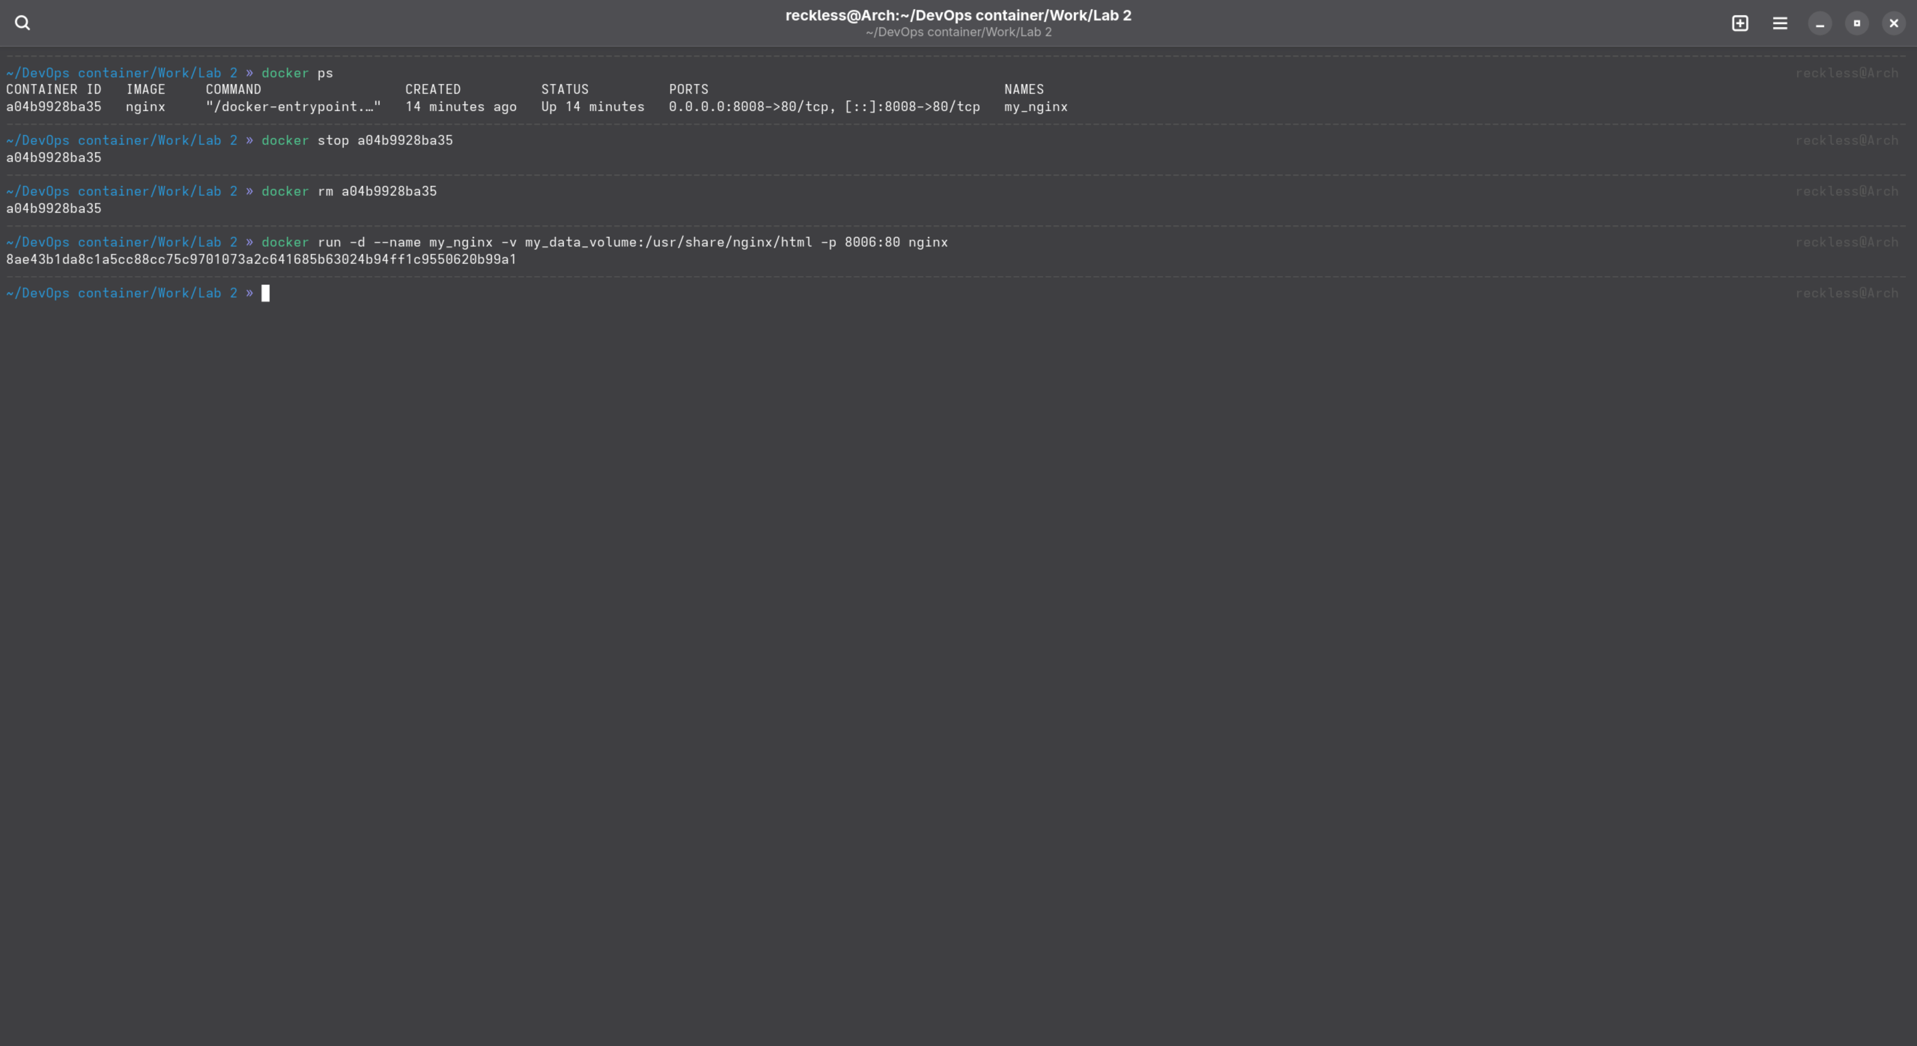
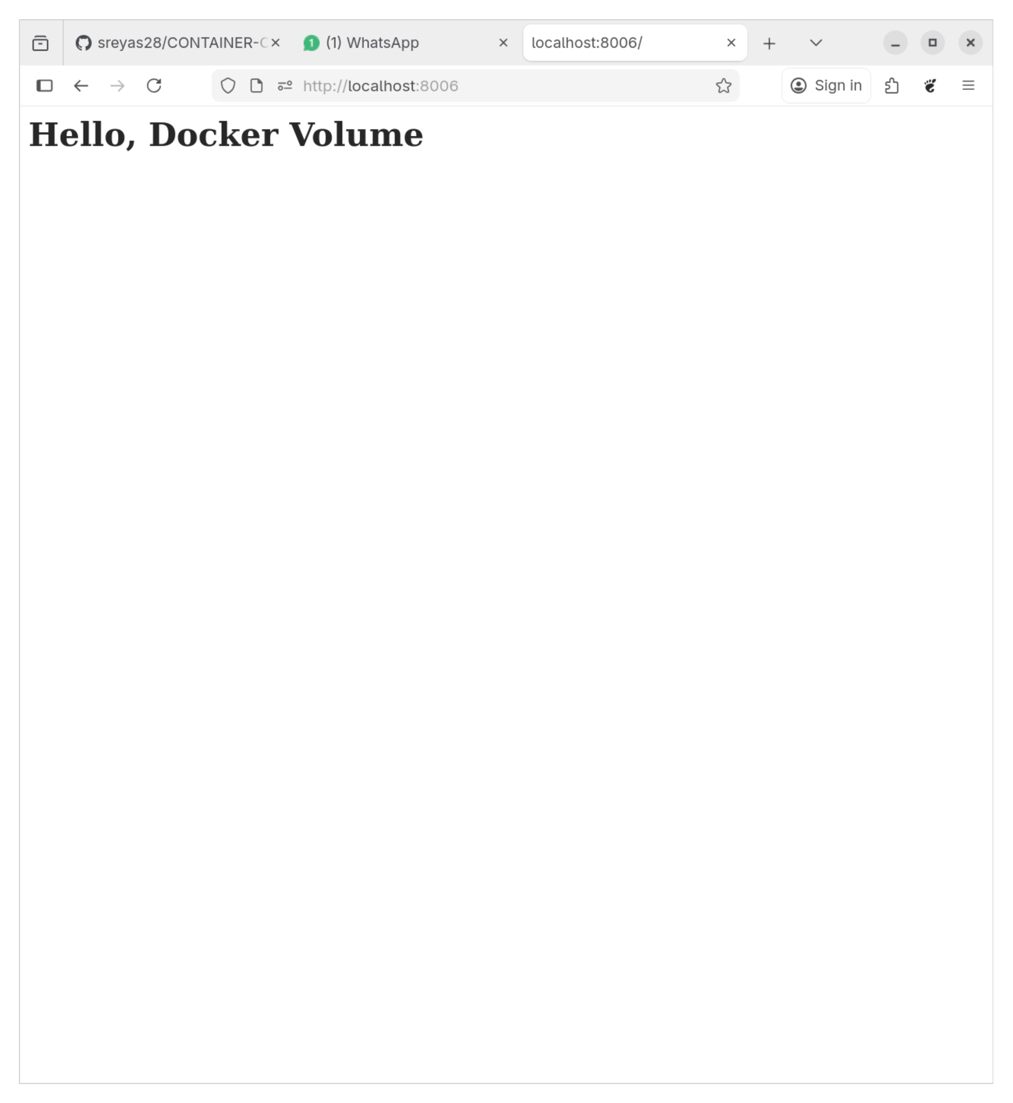
Step 5: Clean Up
Stop and remove the container:
docker stop my_nginx
docker rm my_nginx
Remove the Docker volume:
docker volume rm my_data_volume
Verify that the volume is removed:
docker volume ls
Ensure that my_data_volume is no longer listed.
